 | JOurnal la BISECOMAN  Vol. 06, issue 02 (378-397), 2025  DOI: 10.37899/journallabisecoman.v6i2.2209
The Role of Corporate Strategy in Increasing Student Intake Hotel Tourism Business Ciputra University

Christina Felicia Cen¹, Juan Fiorentino Sutanto¹, Hendra¹
¹Ciputra University, Surabaya, Indonesia
*Corresponding Author: Christina Felicia Cen
Email: cfelicia02@student.ciputra.ac.id
Article Info  Article history:  Received 13 May 2025  Received in revised form 03 June 2025  Accepted 01 July 2025  Keywords:  Strategy, Acceptance, Branding, Partnerships, Promotion  JEL Classification  I25, M31, L84, D83, M19 |  | Abstract  This paper examines the underlying strategic processes relied upon by students regarding decision-making process in selecting the Hospitality and Tourism Business (HTB) course in Ciputra University. The study measures the perceived value, promotional influence, stakeholder dynamics, and institutional attributes that inform the enrolment behaviour through in-depth interviews of current students as participants of a qualitative case study design. The results indicate that students are attracted, not only to the academic material, but also because of that congruence between the institutional identity and the individual goals, especially those goals concerning entrepreneurship, global awareness, and integrated learning. The importance of strategic involvement of stakeholders (i.e. alumni, parents, and industry partners) was identified as a key facilitator and driver of both trust and enrollment performance. For immersive learning environments and experiential resources, professional identity and career readiness were viewed as the main enabling aspects. Such findings support the significance of aligned branding, experiential pedagogy, and stakeholder synergy with higher education strategy. The analysis adds to the body of writing in academic advertising, value co-creation, and identity-based institutional positioning, giving a replicable framework that universities can use to strengthen the competitiveness of differentiation in the active global environment.
Introduction
The phenomenon of college as a means of gaining comfortable knowledge is something that needs to be considered because choosing a major is not just the main thing for prospective students who want to go to college at this time. Therefore, an appropriate corporate strategy is needed to find out the basic needs of prospective students who want to go to college in order to attract prospective students to continue their studies at Ciputra University. In the digital era, the use of social media and online platforms is an important component in educational marketing strategies. This study shows that branding through social media and open house events can significantly increase awareness and increase interest for prospective students in the study programs offered (Xu & Lorber, 2019). In addition, strategic collaboration with high schools has also proven effective in attracting potential students (Pratiwi & Zaini, 2023; Oxman et al., 2025; Shekh-Abed, 2025; Bai et al., 2022).
Ciputra University can also utilize successful alumni as part of their marketing campaign. Alumni who have achieved success in the tourism and hospitality fields are used as real examples to show the added value obtained from education at this university (Espinoza-Figueroa et al., 2021; Berjozkina & Melanthiou, 2021; Mínguez et al., 2021). This approach not only builds credibility but also motivates prospective students by providing an overview of their potential success in the future. Integration of corporate strategies that include digital marketing, alumni engagement, and collaboration with other educational institutions can significantly increase student intake at Ciputra University (Saputra & Aras, 2023; Ramadhan, 2024; Chang, 2022; Dwitasari et al., 2025. The purpose of this study is to explore and understand the various strategies that can be implemented by Ciputra University to achieve these goals. By understanding and applying the right corporate strategies, Ciputra University can ensure that they not only attract but also retain quality students, which in turn will support the reputation and sustainability of the Hotel and Tourism Business study program.
Increasing student intake for the Hotel Tourism Business program at Ciputra University includes a very deep understanding of the dynamics of the tourism industry, global developments, and the needs of the labor market in the sector. As the tourism industry continues to grow globally, the demand for quality workers in this field is increasing. Therefore, it is important for Ciputra University to develop an effective corporate strategy to increase the attractiveness and quality of their Hotel Tourism Business study program, so that it can attract prospective students and meet industry needs (Ho & Law, 2022; Candra et al., 20230.
The tourism industry is one of the economic sectors that has high potential for major growth in Indonesia, especially with the natural wealth and cultural diversity that this country has (Fadli et al., 2022; Rijal et al., 2022; Fatmawati, 2022; Yamin et al., 2021). The growth in the number of domestic and international tourists, as well as the development of the hotel and tourism industry, creates a great demand for skilled and qualified workers in this field. In this context, Ciputra University has a great opportunity to play an active role in supporting the tourism industry through their Hotel Tourism Business study program. The role of corporate strategy in increasing student intake for the program is very important (Jelonek et al., 2022; Huang et al., 2022).
Corporate strategy involves developing a long-term plan that involves determining the vision, mission, and goals of the organization, as well as concrete steps to achieve them (Channuwong et al., 2024; Jimenez et al., 2024). In the context of Ciputra University, corporate strategy must include a deep understanding of the needs of the tourism industry, market trends, and expectations of prospective students. One important aspect of corporate strategy is identifying the university’s competitive advantages in the field of Hotel Tourism Business. This can include modern educational facilities, industry-relevant curriculum, qualified and experienced teachers, and internship and collaboration opportunities with the tourism industry (Yashroy, 2025).
By highlighting these advantages, Universitas Ciputra can increase the attractiveness of their study program to prospective students. In addition, corporate strategy should also include effective marketing efforts to increase awareness of Universitas Ciputra’s Hotel Tourism Business program among prospective students. This can be done through various channels, ranging from social media and the university website to participation in educational fairs and collaboration with educational agents. By increasing the exposure of their study program, Universitas Ciputra can reach more potential prospective students. The role of corporate strategy also includes developing partnerships with the tourism industry, whether in the form of internship programs, project collaborations, or providing employment opportunities for graduates. Such partnerships not only enrich the learning experience of students, but also increase the credibility and relevance of Universitas Ciputra’s Hotel Tourism Business study program in the eyes of the industry. By implementing a comprehensive and sustainable corporate strategy, Universitas Ciputra can increase student intake for their Hotel Tourism Business program.
This will benefit not only the university itself, but also the tourism industry as a whole, by providing a supply of highly qualified and ready-to-use workforce to meet the demands of a constantly evolving market. According to Dr. Marissa Grace Haque-Fawzi, S.H., M.Hum., M.B.A., M.H., Msi et al. 2022 in Haque (2022), They stated that corporate strategy is how a company creates value through the configuration and coordination of activities in its markets. Dr. Marissa and colleagues (2022) also emphasized that corporate strategy is a decision made by top management, including determining the scope and objectives of the business, as well as the initiatives and resources needed to achieve those goals.
Marketing strategy, which is guided by top management decisions in corporate strategy, involves determining how, when, and where to compete. These two types of strategies are interrelated, with corporate strategy setting strategic direction, resource allocation, and existing constraints. Meanwhile, executives in charge of marketing must inform corporate strategists about external changes in the market, both opportunities and threats (Cravens & Piercy, 2006). There are 3 main types of corporate strategies, namely, Growth strategy, stability strategy, and renewal strategy are some types of corporate strategies. Growth strategy is a strategy used by an organization when it wants to grow by increasing the number of products offered or expanding the market served, either through existing businesses or through new businesses (Malesev & Cherry, 2021; Sutaguna et al., 2023). Organizations can grow through concentration, namely by increasing the number of products or expanding the market according to the main business line, through vertical or horizontal integration, or through diversification related or unrelated to the industry being run.
Stability strategy is a corporate strategy characterized by no significant changes in the activities currently being carried out by the organization. In contrast, renewal strategy is a corporate strategy designed to correct weaknesses in the organization that have the potential to cause a decline in performance. According to them, there are two types of renewal strategies: retrenchment strategy, which is short-term, and turnaround strategy to address serious performance problems in the organization. In essence, strategy means the main ways needed to achieve a goal. Kumar (2024) Strategy is defined as a means of making decisions and actions that can improve the long-term performance of an organization.
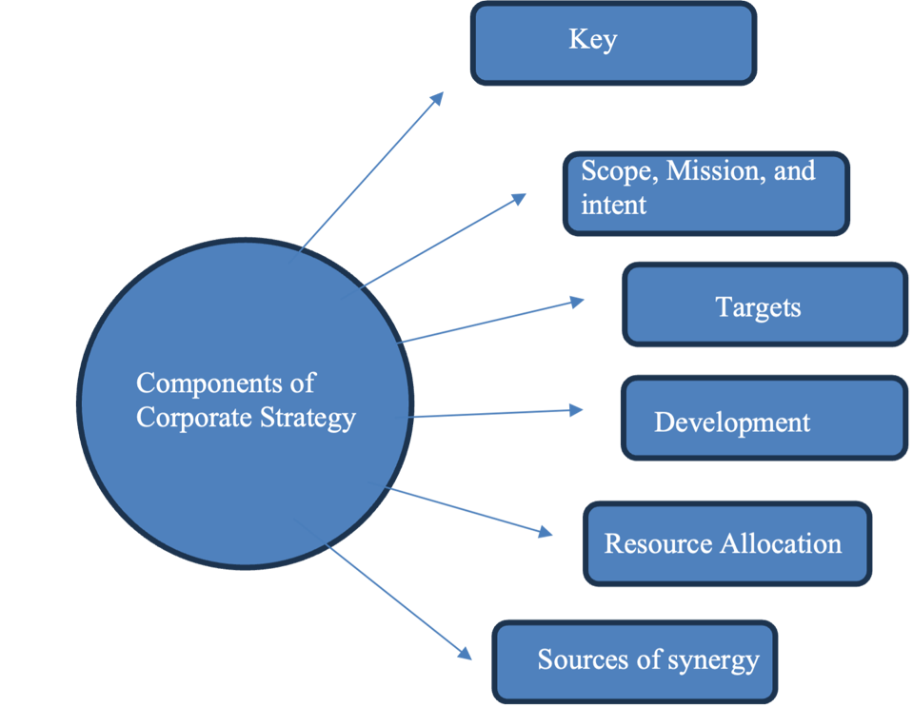
Figure 1. Components of corporate strategy
They explain the importance of strategy for marketing managers, stating that through strategic marketing, managers can establish plans or roadmaps to determine how to do business, compete effectively, and attract and satisfy customers in order to achieve organizational goals. In addition to its main benefits in anticipating environmental turbulence, complexity, competitive intensity, and rapid technological change, marketing plans are also considered beneficial for organizations and managers. It is also useful for non-marketing functions in identifying sources of competitive advantage, helping business development through an organized approach, developing specialization, clarifying roles, and improving coordination. Kumar et al (2024) quoted the opinion of Bergen et al. (1992), Cravens & Piercy (2006) they mentioned the components of corporate strategy and the key issues of these components.
Methods
The present paper is a qualitative research study based on a case study design aimed at exploring effective methods of boosting student enrolment in Hotel and Tourism Business (HTB) study program in Ciputra University. the qualitative approach is used to facilitate the in-depth exposure of the personal and institutional experiences, views, and actions, thus, giving the researchers the chance to get detailed information of the experiences of each of the involved all parties. According to Haryono (2023), qualitative research is best applicable where the researcher wants to know the meaning and context of human actions, mostly during social conduct such as education. According to Sugiyono (2023), it is also important to note that qualitative techniques should be exploited where the purpose of a given research is to unearth trends in thinking and behavior through interpretive decision-making. Following these methodological tenets, the research problem of this study is to be addressed through the prism of the perceived and, in fact, implemented corporate strategy at Ciputra University to make its HTB program more appealing.
The research site is the Ciputra University located in Surabaya, Indonesia. The reason behind this choice is in the fact that this institution has been traditionally oriented towards having more entrepreneurship-focused education and has been actively engaged in advancements of the study of hospitality and tourism profession in a competitive environment of higher education. Ciputra University comes in as an apt example of the case study area due to its strategic intentions of coordinating business studies with industrial experience in the tourism sector. The geographic location of the university in the city of Surabaya, a key urban and economic center and a place with a relatively young tourism industry, also increases the topicality of the university as an object of consideration of higher education marketing strategy and recruitment in Indonesia.
The subject population of the study will involve being composed of both active and prospective students in the HTB program. These two groups are core to study because they give reflections and futuristic views regarding the promotional strategies of the university. To obtain the individuals that are relevant in terms of knowledge and experiences, the researchers used a purposive nature of a sampling technique. Nanda (2023) confirms that purposive sampling is good in identifying people with much information who fit into a given criteria that is essential in answering the research questions. Eight participants were chosen, and they were five students who had actually joined the HTB program and three students who had an experience of interaction with the university due to the outreach activity or digital promotion. The sampling method will make the data gathered to be relevant and in that, based on actual life interactions with the strategic communication of the university.
The data were collected by the in-depth interviewing and participant observation enabling the combination of the personal experience and contemporary behavioral data. The rich interviews allowed the researchers to investigate the experiences, viewpoints, attitudes of the interviewees about the marketing and admissions approaches used by Ciputra University. Face-to-face interviews were informally carried out by using the semi-structured interview guide that would direct the discussion but allow the participants to expound on issues they thought were important. Each of the interviews took 30-40 minutes. The questions were open-ended, which allowed investigating personal motifs further, personal attitudes concerning university branding, and outreach programs success. The practice is consistent with the guidelines provided by Pahkeviannur (2022), according to whom interactive dialogue in qualitative research is significant to explore the hidden rationale and situational factors.
Participant observation was also undertaken in tandem with the interviews to supplement the verbal information with information on contexts and behavior. The study researcher witnessed promotional activities that were conducted by the university, like the education fairs, presentations in the partner high schools, and the experiential marketing activity, the fun trip. Such observations were comprehensively reported in the field notes that was directed at the organization, content, and presentation of the promotional activities together with reactions and interactions of the prospective students. Murdiyanto (2020) asserts that participant observation in qualitative studies is effective in examining natural behavior on the scene and confirmation of congruency between the claimed strategies and practices. This approach is useful in substantiating critical firsthand information on how the corporate strategy was used in carrying out major recruitment processes.
The instruments and sources of researches that were used in this study were semi-structured interview questionnaires, digital audio devices used to accurately record interviews, observation forms and tally charts, field records and notes and university publications like brochures and online resources. The instruments were core to the consistency of data collection, enhanced reliability and cross-validation of data by means of triangulation. The presence of institutional marketing artifacts enabled the researchers to centralize the ath-statements and ath-observations of the participants in general promotional context of Ciputra University.
The thematic analysis methods were used in data analysis process. Transcription of the recorded interviews and systematic review of observation notes was done as a start of the process. The researchers re-read and re-read the transcripts to become very conversant with the contents. Then, initial codes were detected, which are essential notions or repetitive patterns throughout the data. These codes were summarised into broader topics such as social media branding, alumni engagement, high school partnerships and effectiveness of promotional events as they are strategic categories. Following the advice of Fadli (2021), thematic analysis is effective in the process of discovering standings of interpretation and making interpretive connections between themes in the qualitative data due to their specific way of identification. It is this formal but versatile analytical process which enabled the research team to determine the strategic aspects that seemed to have played the greatest role in student decision-making.
Result and Discussion
Issues of Advance Planning and Decision Criteria of Students
The study program in Hotel and Tourism Business (HTB) at Ciputra University works in the competitive educational environment that is becoming overcrowded. The current drop in the number of applications by students has become one of the main issues facing the institution and the question on how institutional strategy should be re-designed to remain competitive and relevant is in the pipeline. Concurrently, the decision-making processes of prospective students reveal a dynamic interplay of intrinsic motivation, social influence, and perceived programmatic value. This section unpacks these strategic challenges and explores the key factors shaping enrollment decisions, using both institutional data and student narratives.
Declining Applicant Numbers and Strategic Gaps
Quantitative trends over the last six years show a gradual but steady decline in HTB student applications—from 75 in 2020 to just 56 in 2025 (as of April). This downward trajectory is visualized in the figure below.
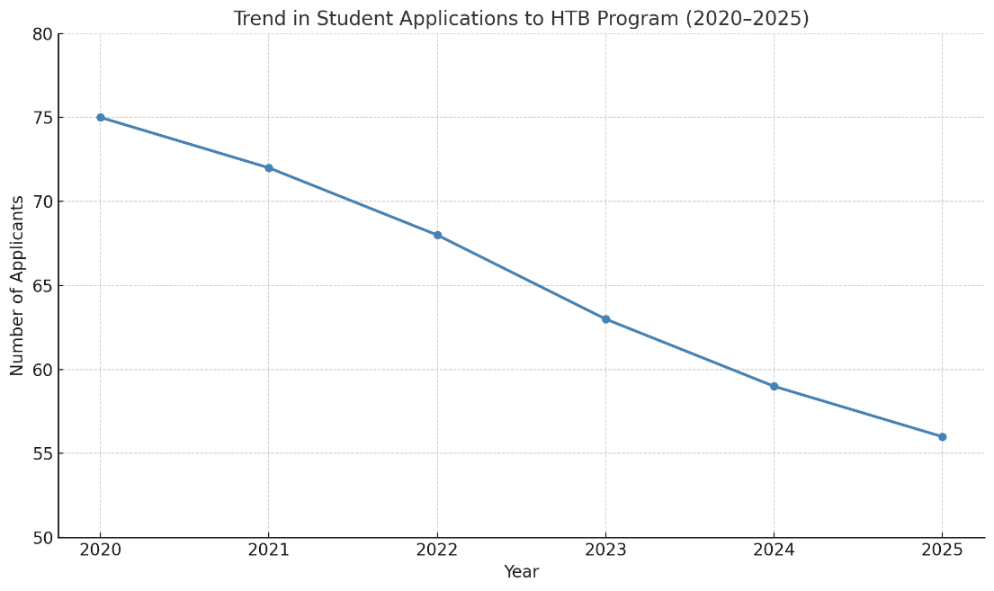
Figure 2. Trend in Student Applications to HTB Program (2020–2025)
The monotonous decrease, which consists of a proportional change of 25.3 percent shows not only annual fluctuations. It is an indication of pressure on the structure of higher education due to higher competitiveness among institutions, changing career demands of students, and a generational drift towards internationally mobile and digitally applicable course. The intake of 60 students in 2025 was almost meeting the institutional goal, but the inability of the campaign to exceed this number means the restrictions of the traditional promotional channels. This trend requires a two-prong response as a strategic imperative. On the one hand, the market segmentation and messages that were offered by Ciputra University need to be reconsidered to fit the new aspirations that are realized by students. Alternatively, more profound curricular development and globalization are required to restore passion in hospitality training when there are other competing fields that seem to be more future-proof.
The information obtained as a result of interviewing five currently enrolled students and three prospective students indicated many central themes that made them decide to enroll in the HTB program. These aspects are as highlighted below.
Table 1. Key Factors Influencing Student Enrollment Decisions
Factor Category | Specific Elements Mentioned | Frequency of Mention
Personal Interest | Passion for tourism, hospitality career goals | 6 out of 8
Alumni Success Stories | Inspired by alumni achievements, social proof | 4 out of 8
Family Influence | Parental guidance, family encouragement | 5 out of 8
Program Distinctiveness | Double degrees, student exchange, practical learning | 6 out of 8
Institutional Branding | Entrepreneurial focus, industry relevance | 4 out of 8
International Exposure | Study abroad, global outlook | 3 out of 8
The results highlight the multi-dimensionality of the decision making of the students. Passion to the industry of hospitality and the attraction to specific program niceties, i.e. the possibility of getting a double degree and the possibility to take part in the exchange programs, take center stage. Nonetheless, social conditions especially the influence of the parents and alumni are also very powerful. Students never make decisions on their own but together with trusted individuals who confirm their educational decisions. Corporate strategy therefore has to be multi-faceted: addressed to the ambition of the students as well as the expectations of the family network as well as the alumni approval.
To shed more light on such data, some quotes of interviews will provide more explanations of the intentions when choosing HTB Ciputra:
“I chose HTB at Ciputra because it aligns with my passion in tourism and I saw how successful alumni made it in the industry. It made me feel like I could achieve the same.”— Active student, Year 2
This quote provides us with a sense of how aspirational identity construction has a part in educational choice. The student also talks about a personal interest in tourism, but more importantly, a certain feeling of projected success is confirmed by alumni success and demonstrated to them. In such a manner, alumni also serve not only as the testimonials to an institution, but also as the metaphorical stand-in of social mobility and professional legitimacy. Corporate strategy-wise, this means that the inclusion of alumni career paths should not be viewed as a secondary capability, but it is indeed at the heart of creating identities constructed around imagined futures of potential students. These success stories help in the operationalization of the university brand promise and must be narrowed into the promotion texts, ambassadorship, and the mentorship programs.
“Actually, it was my parents who really pushed me to choose UC. They said it had a strong reputation in hospitality, and they trusted it more than other universities.”— Prospective student, Grade 12
The story reveals a sociocultural phenomenon that is inherent and highly embedded in the Indonesian and Asian education market in general: the co-decision making! Here, this perception of the institutional prestige forms the guiding agency of the student, and arguably, replaces it. It implies that the corporate approach of Ciputra University should have a two-point track message: one that targets students by influencing them with the notion of innovation and opportunity and another one targeting parents with the message of trust, tradition, and institutional credibility. Failure to take note of this family dynamic can lead to misalignment of messaging and dropped conversion opportunities, particularly in high-investment industries such as hospitality.
“The double degree and exchange programs caught my attention. I wanted more than just classroom learning—I wanted international exposure, and UC gave me that option.”— Active student, Year 1
This quote underlines the more experiential, more global, orientation of today student expectations. The person is not selecting a university based on what it is teaching only, but the kind of experiences it is offering or rather indicating that the individual is ready to move to the international job market. The mentioning of the learning taking place beyond the classroom shows that the values system has changed among the students of learning consumption into overall identity formation. In the case of UC, this further establishes the necessity to position international mobility, practical training, and international partnerships as the main structures of its marketing story. Furthermore, such programs must be framed not simply as perks, but as core competencies that distinguish HTB UC from regional competitors.
Marketing, Promotion, and Stakeholder Engagement Strategies
Ciputra University has adopted multiple engagement and marketing techniques to solve the dwindling enrollment problem and make its Hotel and Tourism Business (HTB) program become more recognizable. These are the conventional campaigns, online outreaches, experiential campaigns and stakeholder-led advocacies. This theme addresses how such strategies were executed and what role they have played in accordance with the student testimonies and observational data, especially the role stakeholder synergy, such as schools, alumni, families, and digital influencers plays in strengthening the brand identity of the university.
The questions were to be answered by the students regarding the strategy they were used to promoting the program or reaching out to the students to make them consider or participate in the HTB program. It was found out that there were six main categories. The frequency of their mention is indicated below.
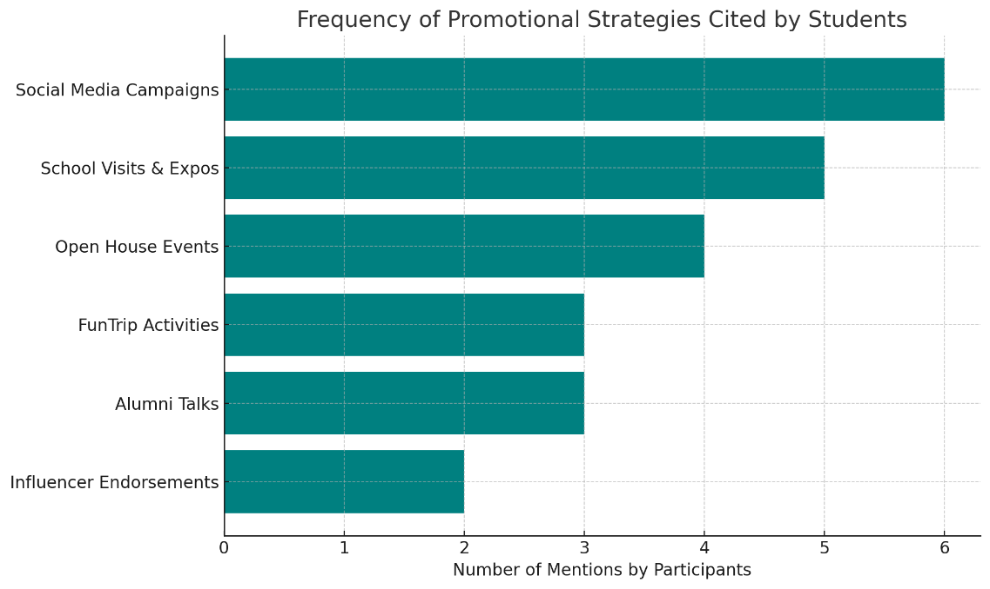
Figure 3. Frequency of Promotional Strategies Cited by Students
The most commonly mentioned source of social media campaigns (6 out of 8 participants) and school visits and expos (5) followed by open house events (4), FunTrip experiential programs (3) and alumni talks (3), and influencer endorsements (2). This ranking indicates that proper outreach needs both online and offline components: the social media to initiate the interest and face-to-face occasions to transform interest into intent.
It does appear that there is a duality effect on promotional role, where the traditional methods of face to face engagement are critical in the development of the sense of credibility and commitment whereas the online presence has become prominent in terms of first contact. Strategically speaking, Ciputra University must not regard these approaches as binary, but instead, put them in a deliberate order: hooks (social media), experiential or stakeholder mediated substantiation. The lower (compared to other groups) mention of influencers can also indicate a demand of better targeted corresponding of influencer identity with institutional values. A generic influencer can create visibility not necessarily trust or programmatic relevance.
Table 2. Stakeholder Involvement in Promotional Engagement
Stakeholder Type | Role in Promotion | Participant Mentions
Partner High Schools | Host for presentations, distribute brochures, recommend UC | High (5/8)
Alumni Ambassadors | Share success stories, speak at events, featured on media | Moderate (4/8)
Family Members | Encourage application, share perceptions of UC | High (5/8)
Digital Influencers | Promote via TikTok/Instagram; attract curiosity | Low-Moderate (2/8)
Faculty/Admin Staff | Lead open house, deliver presentations, guide campus tours | High (6/8)
In this stake holder matrix, it can be observed how the success in the promotion of the HTB program relies on the distributed ecosystem of credibility. Each group serves a different communicative purpose: Faculty is to convert program complexity into value, families represent a source of trust, alumni represent the source of motivational modeling, and schools are the platform of endorsement. More importantly, the location of each node of this network touches on a varying phase of the student in cognitive and emotional thought process. This has an implication of how UC should strategically form its promotional strategy as a choreographed multi-stakeholder approach and not a broadcast system. This also confirms the importance of strategic tie-ups- not only in relation to marketing investments.
“I first saw UC on Instagram through a travel influencer who talked about FunTrip. It felt fun and real, not like a formal ad. That’s what got me curious enough to join the info session.”— Prospective student, Grade 12
This quotation shows a significant intergenerational change in terms of the assessment of the authenticity of promotions. The customary adverts are highly ignored as being scripted or impersonal, whereas follower-type influencer assisted content is considered to be believable due to the relatability and informality. The most important takeaway here is not only the channel (Instagram) itself, but the way and style it is messaged. With the help of influencers taking on a narrative style (what it is really like) UC can infiltrate the media-savvy audience that values emotional realism more than the formal persuasion. Strategically it would mean that user generated content and micro-influencers with closer niche followership and higher rates of engagement could be more effective at driving curiosity and action than medium to large campaigns.
“The open house really helped. I brought my mom, and she liked how the lecturers explained the international program and showed us the facilities. That’s when we felt sure this was the right choice.”— Active student, Year 1
This is a quote that contracts the conversion of institutional experience embodied. Open houses serve a purpose other than providing information when they use the multi-sensory experience as a platform to assess concrete evidence of quality in the form of facilities, faculty articulation and institutional ethos along with the standards of the fellow students. The student emphasizes the group aspect of the making decision, also, it is important: it was a group decision: we were certain, the student writes, and co-evaluation of the family is implied. The implication for UC is twofold: (1) open houses must be curated as narrative-rich events, not merely walkthroughs; and (2) they must provide differentiated messaging streams—technical, emotional, and cultural—to simultaneously satisfy students’ aspirations and parents’ risk aversion. These events should not only explain offerings but demonstrate outcomes and identities that families can confidently invest in.
“Our school invited UC for a hospitality expo. They brought alumni who talked about their careers. It was the first time I thought, maybe I could do this too.”— Active student, Year 2
This assertion contributes to the mechanism in which alumni can be taken as cognitive catalysts by self-identification. The student does not mention features of the program, ratings, or promotional images, but the impact of observing a person like oneself attain professional success in life. Here, the alumni transfer institutional value focused on abstract prestige to a possibility that relates to them. The strategic lesson to be learned involves making the alumni engagement local and demographically consistent. Both geographic, socioeconomic, or cultural proximity of the speaker to the target audience promotes the effect of alumni storytelling. To be most effective, UC will want to invest in an alumni ambassador program that selects speakers, trains them, and rotates them systematically: this is a process where speakers, chosen because they may most readily reflect the student background, focus on portraying the more inspired brand of the university.
Departmental Strength and University Vision
The Hotel and Tourism Business (HTB) program of the Ciputra University has a distinct institutional mission that revolves around the concept of entrepreneurship, global competence, and practice and applied learning. It is not just a visionary idea that is realized in the mission; rather, it is a goal that is instilled within the branding of the university, its pedagogy, and at the level where international liaisons are made. Within this theme we examine how far the institutional mission is seen in the lived experiences and self perceptions of the students at the university. Looking at what has been elicited in the interviews against what has been currently outlined as strategic direction, we are in a position of evaluating the process of effective incorporation and implementation of the corporate strategy within the university through the process of the student life.
Interview analysis will show that the most important elements of the HTB program mission, including entrepreneurial learning, international orientation, and the practice at the real world, are known and valued by students very popularly. This convergence can be defined as follows in a conceptual alignment chart:
Table 3. Alignment of Student Perceptions with Institutional Mission
Institutional Mission Element | Student Perception (Observed Themes) | Degree of Alignment
Entrepreneurship-oriented education | Seen as unique, empowering, skill-building | Very High
Global outlook and international mobility | Strongly valued, especially double degrees and exchanges | High
Practical, real-world learning | Repeatedly affirmed via FunTrip, labs, and fieldwork | High
Leadership and business mindset | Identified through self-confidence, career readiness | Moderate–High
Innovation and creativity | Mentioned in terms of “creative freedom” and flexibility | Moderate
Academic rigor and theoretical depth | Rarely cited directly; less emphasis in student narratives | Low–Moderate
This convergence indicates that the strategic messaging and educational design of this university is well received with its student body- especially in such aspects as entrepreneurship and global orientation. However, the limited emphasis on academic theory or research depth implies a potential gap in students’ valuation or awareness of academic rigor. Strategically, this may represent a branding blind spot that should be addressed, especially if UC wishes to enhance its academic reputation or attract postgraduate candidates.
“The entrepreneurship part of HTB is what makes it feel different. We’re not just learning how to serve or manage a hotel; we’re learning how to think like an owner.” — Active student, Year 2
This is an epistemological change that Ciputra University has imparted in their students; it is the process of transitioning to the form of vocational service-based training to the form of entrepreneurial self-agency. The high capitalization of the think like an owner has a connotation that indicates that students are digesting business-savvy not as knowledge, but as character. That corresponds to the institutional objective of developing not only workforce to the hotel industry but also innovators and innovators thereof. The strategic wisdom of this is immense: it implies that the curriculum of HTB is not merely conveyance of information but the alteration of philosophic perspective. To UC, it means being able to leverage these transformation stories in marketing efforts further with the aim of standing out even more among the competitors who provide hospitality education to a greater degree of satisfaction that is task-oriented.
“What I like is that we’re pushed to do real projects. It’s not only theory, we’re building ideas, making proposals, pitching—just like real businesses.” — Active student, Year 3
The student in this case shows the emphasis on performative and immersive quality of HTB pedagogy. The term: pushed to do real projects implies that the program is not merely an experience- it is demanding, taxing and growth-inducing. This makes a difference in the pedagogical perspective on design: the curriculum is not inactive or superficial, but requires action, problem-solving and presentation to others (e.g., pitching). This virtually enacts the entrepreneur life cycle on a secure academic platform, which provides cognitive as well as emotional rehearsal against uncertainty in the real world. Strategically, this confirms that UC is not only motivationally right to make its investments in project-based learning, business incubation and mentor involvement but it is strategically imperative to position the HTB graduates as flexible and employable professionals within uncertain markets.
“I used to think hospitality was just about service, but UC taught me how it connects to innovation, branding, and starting something new.”— Prospective student, Grade 12
In this quote, we can find a cognitive shift in the meaning of hospitality education. Earlier considered as a service-oriented discipline, the student views it as an interdisciplinary platform synergized with entrepreneurship, innovation, and stratagem management. The notion that the concept of hospitality is linked with branding and the launching of a new business implies that UC has managed to recontextualize the sphere, stepping over traditional stereotypes, and providing it with the status of a gateway to creation of greater values. This is a clarion call of deep strategic success: HTB will not only rank as a source of entry-level trainers in the hotel industry, but an incubator of lifestyle entrepreneurs and experience designers as well. In the case of institutional planning, the recommendation is that this type of future program development ought to keep frustrating borders between hospitality, design thinking, and digital innovation in order to sustain this larger identity.
Value Creation of Learning and Resources Allocation
In HTB program, the process of learning in Ciputra University is not only determined by the content of the curriculum, the characteristic learning in the program is, in a sense, due to its manner of resource deployment and synergizing. Such assets are tangible (infrastructure and technology), human (faculty, alumni, mentors) and social (parents, partnerships, digital networks). Rather than support mechanisms, these components are agents of education, impacting perceptions of quality, relevance, and transformation, on the part of students. In this theme we explore the experience and student interpretation of these resources and the implications they have in regards to the strategic design of the learning ecosystem at UC.
Students continue to express that the achievement of their learning results and professional development is not only linked to the teaching process, but also to the overall learning conditions such as physical place, interactions with various stakeholders, and working with projects. Such perceptions were not abstract; the perceptions were much embedded with emotional, social and identity-forming experiences.
Table 4. Resource Allocation vs. Student-Perceived Learning Impact
Resource Type | Specific Assets/Activities | Student-Perceived Impact
Physical Facilities | Demo kitchens, hospitality labs, fine dining setups | Very High – perceived as spaces for “professional rehearsal”
Digital Engagement | Social media, interactive promotional content | Moderate to High – emotional connection and brand awareness
Human Capital | Faculty, mentors, alumni speakers | Very High – credibility, mentorship, motivational role modeling
Industry Partnerships | Internships, site visits, job pipelines | Very High – contextual application and career worldview
Social Capital | Parental advocacy, alumni trust, community testimonials | High – trust-building and decision reinforcement
Experiential Programs | FunTrip, real projects, study exchange programs | Very High – transformative, immersive learning experiences
This matrix has helped us understand that students are valued not only by the content in formal coursework, but rather by an ecosystem system of resources that emulate and bridge them to the real-world practice. Amazingly, physical infrastructure and experiential learning do not get in the imagination as perks, but as the fundamental foundation of competence and identity construction. The consistency across high-impact categories signals the university’s strategic coherence: its resources are integrated to reinforce its entrepreneurial, applied, and globally minded ethos.
“The hands-on kitchen was the first time I really felt like a professional. It’s not just theory—we’re working with real tools and real situations.”— Active student, Year 3
The quote is a perfect representation of what can be referred to as embodied professionalization, i.e. a process of pedagogical transformation as a result of which students acquire not only specific knowledge, but also adopt the subjectivity of a practitioner. The practical kitchen is not merely a learning place, it is an identity changing environment in which the students act as their future incalculations. As a sociocultural learning theory, this can be seen as a point of acceptable peripheral participation, where students are not simply studying hospitality, they are filling in the role of a professional in a legitimate setting of practice. In terms of strategic planning, this implies that the distribution of physical resources must not be narrowed in the form of infrastructure finance plans, but rather as investment in identity formation and self-efficacy. The language the student uses demonstrates how space can be used to indicate authenticity and strengthen the feeling of belonging within a professional community practice. In case of UC, this establishes beyond doubts that facilities are not merely utilitarian, but symbolic resources as well.
“When alumni came and shared their stories, I felt like they were one of us. They made it. It makes you believe you can too.” — Active student, Year 2
This story is part of the affective aspect of aspiration. Alumni are people working as seen success stories and when they represent it publicly, they are not mere results, but representatives of possibilities. All the attention the student brings to the recognition detail (“they were one of us”) implies that the value that alumni storytelling carries is more relational closeness than selectivity. The achievement of alumni is not inspiring when it is remote but just because it seems to be imitable. This is psychologically achieved through the concept of social modeling, which holds that the ability to understand how to perform better in life is improved, by watching similar others and being able to relate to them succeeding. In the case of UC, this confirms that alumni engagement is not an adjunct activity, but rather a type of strategic value delivery, the evidence of institutional credibility, and emotional support to the wishing of the current students.
“My internship at a partner hotel changed how I see the industry. It wasn’t just a job—it connected everything we learned in class to the real world.”— Active student, Year 3
The testimony is a testimony of a profound moment of epistemological unity i.e. in the fragmented academic material is given a meaning by being brought to the real world. In the development of this thinking, it is important to realize that the internship is not simply a professional tool but is more of a mental tool to fill the gap between hypothetical theory and the actualized complexity. There is an indication of transformative effect on professional worldview through the phrasing of the student. Internships provide students an opportunity to prove hypotheses, confirm the applicability of the skills and to get acquainted with the context which no classroom can remotely resemble. Strategically from a student learning arc perspective this shows the high value of industry partnerships as a means of graduating motivated and able students with career relevant skills and motivation, learning how to learn, and self directed. This means that internships are part and parcel of curriculum architecture and they should not be an afterthought as an external requirement in UC.
Institutional Identity, Stakeholder Synergy and Value Perception of Strategic Alignment
The HTB program at Ciputra University portrays a strong organization of strategy-to-experience conversion that goes into student use, stakeholders, and brand value in the long term. This has not happened by chance rather has been achieved through consistent strategies, enterprise-wide alignment, resource strategy, and planning. The results confirm that, when keeping learning environments aligned by identity formation, social capital and experiential value, institutions will be able to shift in the educational delivery flanked with transcending transactional education to transactional one. This is in accordance to Whitchurch (2012) higher education evolution where the value of a university ceases to be limited only by the communication of physical knowledge but is by the capacity of an institution to assist students in crafting their future sense of identity, their placement(s) in society and their career capital.
The notable aspect of this research is that there is a high degree of congruence with the values possessed by institutions and held by students. The concept of entrepreneurial thinking, applied practice, and international exposure was mentioned repeatedly as defining aspects of students experience by the students in the HTB program, not as marketing concepts. This implies that this institution has been able to attain what Balmer & Greyser (2006) refer to as the “strategic brand alignment” in which internal culture and external promise are synergistically fused. Organisations which manage to have this type of alignment tend to enjoy greater trust by students, enhanced brand loyalty and better word of mouth marketing (Helgesen & Nesset, 2007; Chapleo, 2011). The alignment is specifically strong in the UC case, where the values are ambitions followed both on a personal and professional level, like self-efficacy, readiness to be a leader, and the ability to adapt to the global conditions.
In addition, the fact that the university is able to engage a stakeholder based recruitment and retention strategy is another demonstration of a progressive institutional agility. Instead of being based on top-down promotion initiatives, UC enlists a bottom-up network of interested agents, such as alumni, parents, industry partners and faculty, who all play a hand in reinforcing the validity of the institution. This is in near-reflection of the stakeholder theory of Kujala et al. (2017), albeit with newer elongations by Loureiro et al. (2020), who remember the issue of stakeholder co-creation in service industries. When applied to education, such techniques generate distributed trust networks, in which potential students get similar institutional messaging from conditions in multiple relationships with credible sources that help build sustained trust. The validity of this strategy can be explained by the results of Weerasinghe and Song et al. (2014) who claim that recommendations of families, peers, and alumni are more convincing than institutional advertising in high-context cultures. The model by UC is a more developed implementation of this idea, as it is making every group of stakeholders an instrument of power and brand enhancement.
Another aspect of the program that requires a lot of attention is the embedding of the mechanism of experiential learning. The internship, simulation project, and practical kitchen training do not merely act as teaching and learning methods, but they work as enhancers of the capability. The experiences enable the students to role play as professionals, experiment with business models and internalize entrepreneurial behaviour hence reflecting the educational construct by Kolb (2015) and Lave & Wenger (1991). It is essential in terms of employability and future flexibility that are linked to the correspondence between theory and practice. Given the results presented by Rae (2006), entrepreneurship education experiences involving authentic experiences causes better entrepreneurial intentions and a higher start-up success of the businesses, relative to graduation. The benefits of having these features embedded in the curriculum of HTB, as opposed to being additional, places the institution of UC among the leaders in higher education best practices.
The seen relationship between infrastructure investment and value regarding students is also worth further explanation. Not just students were delighted with the availability of physical infrastructure, such as hospitality labs and demo kitchens, but made the direct associations with their motivation in learning, professional confidence and future preparedness. This result is also replicated in a study by Silva et al. (2017), which revealed that perceived service quality in higher education has been affected by physical demonstrations of investment, particularly in applied and professional domains. what more, the behavioral economics may refer, to the evaluations of the behavior, visible allocation of resource might initiate the so called, reference point adjustments (Kahneman, 1979), the students would re-adjust their expectations upwards and note the university as more serious, competent and committed. Resources are by no means neutral in this term they are actually semiotic resources summoning the institutional will and encouraging student responsiveness.
The most tactical discoveries in this study include the fact that students do not perceive themselves to be passive recipients of education rather they are the active participants of a co-creative process. The way they refer to self-discovery, identity and vision of the future demonstrates a more profound psychological involvement into the educational process. This finding corresponds to the idea of educational identity developed by Gecas (1982) and upheld in present-day literature on student development, according to which self-concept is influenced by the immersive, supportive, and purposive learning environments. Through the HTB program, which integrates worldwide exposure, entrepreneurial framing, and practical application, UC has managed to create the perfect arena in which identity transformation not only becomes an option but, ideally, a component of the designed structure.
Moreover, the assimilation of global learning pathways- including student exchanges and double degrees have associated symbolic and functional worth. These opportunities are symbols that indicate status and international relevancy. They contribute to the general knowledge of the students about cross-cultural competence, which is an important distinguishing factor in the global labor market (Altbach & Knight, 2007; Clarke & Kirby, 2022). As global universities continue to fight to secure globally-conscious students, the competitors who will establish smooth connections between the levels of teaching within the nation and the possibilities to travel internationally will be permanently ahead of them. At the HTB program, the international exposure is not just some abstracted idea but rather concrete, realizable and integrated in a learning design mode.
The position of alumni, which is emphasized in the accounts of students, serves a very specific strategic purpose. Alumni are not just the example of the successful results, they are the authors of the narrative with the social proofs and the emotional authority to their voices. According to Moogan (2011) alumni role in identity construction and encouragement of attainment of enrollment, especially through the use of their transformation and agency narrative, has proven to play a major role in enhancing enrollments. UC has been smart enough to employ the alumni in both promotion and development which reflects high brand literacy. It also acknowledges that alumni do not represent another episode or relic in the history of the university but an active part of its living brand, within which they can help to define the expectations and imaginations of people in future cohorts.
Lastly, this paper offers an account of how higher education institutions may create systemic impact by means of orchestration. Each of the components, brand positioning, stakeholder activation, experiential learning, resource visibility, and identity formation are useful in their own right. Nevertheless, they become powerful through integration. The HTB program of UC is not a collection of separated innovations but rather they form an ecosystem where the components are strengthened by one other. This is similar to the principle of strategic fit that Porter (1996) describes in explaining that sustained competitive advantage is not created by the various strengths but rather the ability of the component elements of the system to reinforce each other. The HTB case shows that such fit is not hypothetical--it is possible and it can be observed and duplicated so long as the institutions have the clarity, the commitment and the agility to create towards it.

Conclusion
This paper has highlighted how the HTB program in the Ciputra University represents a high performance education model which is characterized by strategic coherence, stakeholder integration and experience-based value creation. Being nothing more than an academic commodity, the program is a carefully designed ecosystem, in which the institutional identity, student transformation, and market relevance interact. This is certainly being reinforced on the evidence that when colleges and universities build their core values, i.e. entrepreneurship, global readiness, applied learning, into each and every touchpoint of the student experience, they are not just educating; those institutions are creating agents of change such that they can find their way in the most complicated situations as well as redesigning them. The results indicate that strategic fit between promises and delivery of a university is not a marketing role- it is an operational necessity. The integration of the institutional purpose and the teaching strategies at Ciputra University leads to an intense brand encounter that is empowering to students and the societies that they live in. This convergence not only increases institutional credibility, bolsters learner identity, and develops longer-term competitive abilities in a more globalized/performance-opinionated education environment. Additionally, the potential of the alumni, parents, industry partners and faculty to contribute to HTB as a co-creator of value makes HTB program a relationally intelligent and network based model. This synergy, combined with the university’s commitment to experiential and international learning, offers a compelling template for institutions seeking to transcend the limitations of traditional instructional delivery. The HTB program’s structure proves that meaningful transformation in higher education is not the product of isolated innovation, but the outcome of sustained strategic orchestration.
References
Altbach, P. G., & Knight, J. (2007). The internationalization of higher education: Motivations and realities. Journal of studies in international education, 11(3-4), 290-305. http://dx.doi.org/10.1177/1028315307303542
Bai, M., Barletta, W. A., Bruhwiler, D. L., Chattopadhyay, S., Hao, Y., Holder, S., ... & Winchester, S. (2022). Strategies in education, outreach, and inclusion to enhance the us workforce in accelerator science and engineering. arXiv preprint arXiv:2203.08919. http://dx.doi.org/10.48550/arXiv.2203.08919
Balmer, J. M., & Greyser, S. A. (2006). Corporate marketing: Integrating corporate identity, corporate branding, corporate communications, corporate image and corporate reputation. European journal of marketing, 40(7/8), 730-741. http://dx.doi.org/10.1108/03090560610669964
Bergen, M., Dutta, S., & Walker Jr, O. C. (1992). Agency relationships in marketing: A review of the implications and applications of agency and related theories. Journal of marketing, 56(3), 1-24. https://doi.org/10.2307/1252293
Berjozkina, G., & Melanthiou, Y. (2021). Is tourism and hospitality education supporting sustainability?. Worldwide Hospitality and Tourism Themes, 13(6), 744-753.
Candra, P., Mahaputra, M. R., & Mahaputra, M. R. (2023). Service Quality and Customer Satisfaction Have an Impact on Increasing Hotel Room Occupancy Ratio: Literature Review Study. Greenation International Journal of Tourism and Management, 1(4), 400-412. http://dx.doi.org/10.38035/gijtm.v1i4.127
Chang, J. H. (2022). The applicability of undergraduate entrepreneurship curriculum and ecosystem to support startup founders: A study of selected universities in Indonesia. University of Pennsylvania.
Channuwong, S., Phudarat, B. S. S., Jirachottrakul, P., Pleansamai, J. L. K., Khamsom, S., & Kanhabutr, A. (2024). Strategic management for sustainable business development: Concepts, theories and practices. Sciences of Conservation and Archaeology, 36(3), 11-22. http://dx.doi.org/10.57030/sci-arch-36.3.24.2
Chapleo, C. (2011). Exploring rationales for branding a university: Should we be seeking to measure branding in UK universities?. Journal of Brand Management, 18, 411-422. http://dx.doi.org/10.1057/bm.2010.53
Clarke, L., & Kirby, D. (2022). Internationalizing higher education curricula: Strategies and approaches. Universal Journal of Educational Research, 10(6), 408–417. http://dx.doi.org/10.13189/ujer.2022.100605
Cravens, D. W., & Piercy, N. (2006). Strategic marketing (Vol. 7). New York: McGraw-Hill.
Cravens, D. W., & Piercy, N. (2006). Strategic marketing (Vol. 7). New York: McGraw-Hill.
Dwitasari, P., Zulaikha, E., Hanoum, S., Alamin, R. Y., & Lee, L. (2025). Internal perspectives on visual identities in higher education: A case study of top-ranked universities in Indonesia. F1000Research, 13, 1535. https://doi.org/10.12688/f1000research.159232.2
Espinoza-Figueroa, F., Vanneste, D., Alvarado-Vanegas, B., Farfan-Pacheco, K., & Rodriguez-Giron, S. (2021). based learning (RBL): Added-value in tourism education. Journal of Hospitality, Leisure, Sport & Tourism Education, 28, 100312. https://doi.org/10.1016/j.jhlste.2021.100312
Fadli, M. R. (2021). Memahami desain metode penelitian kualitatif. Humanika, 21(1).
Fadli, M., Susilo, E., Puspitawati, D., Ridjal, A. M., Maharani, D. P., & Liemanto, A. (2022). Sustainable Tourism as a Development Strategy in Indonesia. Journal of Indonesian Tourism & Development Studies, 10(1). http://dx.doi.org/10.21776/ub.jitode.2022.010.01.04
Fatmawati, E. (2021). Strategies to grow a proud attitude towards Indonesian cultural diversity. Linguistics and Culture Review, 810-820. http://dx.doi.org/10.21744/lingcure.v5nS1.1465
Gecas, V. (1982). The self-concept. Annual review of sociology, 8, 1-33.
Haque, M. G. (2022). Web 5.0 dalam Sumberdaya Halal sebagai Kearifan Lokal Indonesia (Dr. Marissa Grace Haque-Fawzi), 09-06-2022.
Haryono, E. (2023). Metodologi penelitian kualitatif di perguruan tinggi keagamaan Islam. An-Nuur: The Journal of Islamic Studies, 13.
Helgesen, Ø., & Nesset, E. (2007). What accounts for students' loyalty? Some field study evidence. International Journal of Educational Management, 21(2), 126-143. http://dx.doi.org/10.1108/09513540710729926
Ho, G. K., & Law, R. (2022). Marketing strategies in the decision-making process for undergraduate choice in pursuit of hospitality and tourism higher education: The case of Hong Kong. Journal of Hospitality & Tourism Education, 34(2), 124-136. https://doi.org/10.1080/10963758.2020.1791136
Huang, Y. M., Silitonga, L. M., & Wu, T. T. (2022). Applying a business simulation game in a flipped classroom to enhance engagement, learning achievement, and higher-order thinking skills. Computers & Education, 183, 104494. http://dx.doi.org/10.1016/j.compedu.2022.104494
Jelonek, D., Tien, N. H., Dao, M. T. H., & Minh, D. T. (2022). Comparative analysis of business strategy of Vietnamese real estate developers: the use of Hoffer matrix. International journal of multidisciplinary research and growth evaluation, 3(1), 197-204.
Jimenez, D., Franco, I. B., & Smith, T. (2021). A review of corporate purpose: An approach to actioning the sustainable development goals (SDGs). Sustainability, 13(7), 3899. https://doi.org/10.3390/su13073899
Kahneman, T. (1979). D. kahneman, a. tversky. Prospect theory: An analysis of decisions under risk, 263-291. https://doi.org/10.2307/1914185
Kolb, R. (2015). Peremptory international law-jus cogens: a general inventory. Bloomsbury publishing.
Kujala, J., Lehtimäki, H., & Myllykangas, P. (2017). Value co-creation in stakeholder relationships: A case study. In Stakeholder engagement: Clinical research cases (pp. 15-30). Cham: Springer International Publishing. http://dx.doi.org/10.1007/978-3-319-62785-4_2
Kumar, S. (2024). Strategic decision making and strategic decision practices in intelligent organizations: A review. International Journal of Business and Management Research, 12(2), 31-39. http://dx.doi.org/10.37391/ijbmr.120202
Lave, J., & Wenger, E. (1991). Learning in doing: Social, cognitive, and computational perspectives. Situated learning: Legitimate peripheral participation, 10, 109-155. http://dx.doi.org/10.1017/CBO9780511815355
Loureiro, S. M. C., Romero, J., & Bilro, R. G. (2020). Stakeholder engagement in co-creation processes for innovation: A systematic literature review and case study. Journal of Business Research, 119, 388-409. https://doi.org/10.1016/j.jbusres.2019.09.038
Malesev, S., & Cherry, M. (2021). Digital and social media marketing-growing market share for construction SMEs. Construction Economics and Building, 21(1), 65-82. http://dx.doi.org/10.5130/AJCEB.v21i1.7521
Mínguez, C., Martínez-Hernández, C., & Yubero, C. (2021). Higher education and the sustainable tourism pedagogy: Are tourism students ready to lead change in the post pandemic era?. Journal of Hospitality, Leisure, Sport & Tourism Education, 29, 100329. http://dx.doi.org/10.1016/j.jhlste.2021.100329
Moogan, Y. J. (2011). Can a higher education institution's marketing strategy improve the student‐institution match?. International journal of educational management, 25(6), 570-589..
Murdiyanto, E. (2020). Metode penelitian kualitatif (Sistematika penelitian kualitatif). Yogyakarta Press.
Nanda, S. (2023). Metode penelitian kualitatif: Pengertian, tujuan, ciri, jenis & contoh. Academy Brain.
Oxman, A. D., Nsangi, A., García, L. M., Kaseje, M., Jofra, L. S., Semakula, D., ... & Rosenbaum, S. E. (2025). The effects of teaching strategies on learning to think critically in primary and secondary schools: an overview of systematic reviews. F1000Research, 13, 1426. https://doi.org/10.12688/f1000research.158087.2
Pahkeviannur, M. R. (2022). Penelitian kualitatif: Metode penelitian kualitatif. Jurnal Equilibrium, 5(1).
Porter, M. E. (1996). Competitive advantage, agglomeration economies, and regional policy. International regional science review, 19(1-2), 85-90. https://doi.org/10.1177/016001769601900208
Pratiwi, E. T., & Zaini, A. W. (2023). Social Media Optimization in School Image Transformation: Instagram Interactive Strategies in Schools. Journal of Social Studies and Education, 1(1), 01-12. https://doi.org/10.61987/jsse.v1i1.511
Rae, D. (2006). Entrepreneurial learning: A conceptual framework for technology-based enterprise. Technology Analysis & Strategic Management, 18(1), 39-56. http://dx.doi.org/10.1080/09537320500520494
Ramadhan, F. H. (2024). Integrated Marketing Communication as a Communication Strategy of the International Office of Universitas Islam Indonesia in Attracting International Students (Doctoral dissertation, Universitas Islam Indonesia).
Rijal, S., Arifin, M., Rante, M. W., Musawantoro, M., & Badollahi, M. Z. (2022). The existence of tourism higher education under the ministry of tourism and creative economy (PTNP) toward Indonesia’s golden generation 2045. Linguistics and Culture Review, 338-353. https://doi.org/10.21744/lingcure.v6nS2.2111
Saputra, A., & Aras, M. (2023). The Strategic Frameworks in Digital Marketing Communication for Educational Institutions: A Case Analysis of Universitas Islam Negeri in Indonesia. ILTIZAM Journal of Shariah Economics Research, 7(2), 239-248. https://doi.org/10.30631/iltizam.v7i2.2275
Shekh-Abed, A. (2025). Metacognitive self-knowledge and cognitive skills in project-based learning of high school electronics students. European Journal of Engineering Education, 50(1), 214-229. http://dx.doi.org/10.1080/03043797.2024.2374479
Silva, D. S., Moraes, G. H. S. M. D., Makiya, I. K., & Cesar, F. I. G. (2017). Measurement of perceived service quality in higher education institutions: A review of HEdPERF scale use. Quality Assurance in Education, 25(4), 415-439. http://dx.doi.org/10.1108/QAE-10-2016-0058
Song, Y. A., Ahn, H., & Sung, Y. (2014). Cultural values in financial services advertising: a cross-cultural study of magazine ads in the USA and Korea. Journal of Services Marketing, 28(5), 349-360. http://dx.doi.org/10.1108/JSM-11-2012-0220
Sugiyono. (2023). Metode penelitian kualitatif (untuk penelitian yang bersifat: eksploratif, enterpretif, interaktif dan konstruktif). CV. Alfabeta.
Sutaguna, I. N. T., Achmad, G. N., Risdwiyanto, A., & Yusuf, M. (2023). Marketing strategy for increasing sales of cooking oil shoes in Barokah trading business. International Journal of Economics and Management Research, 2(1), 132-152. https://doi.org/10.55606/ijemr.v2i1.73
Whitchurch, C. (2012). Reconstructing identities in higher education: The rise of'third space'professionals. Routledge.
Wu, S. J., Chang, T. C., & Wu, C. C. (2022). Relationship between experiential marketing, brand image, customer satisfaction and customer loyalty in a tourist hotel. Innovation, 1(1). http://dx.doi.org/10.35745/idc2022v01.01.0004
Xu, Y., & Lorber, M. F. (2019). Impact of digital marketing on student enrollment and engagement in higher education.
Yamin, M., Darmawan, A., & Rosyadi, S. (2021). Analysis of Indonesian tourism potentials through the sustainable tourism perspective in the new normal era. Jurnal Hubungan Internasional, 10(1), 44-58. http://dx.doi.org/10.18196/jhi.v10i1.10500
Yashroy, U. (2025). Collaboration of Academia and the Tourism Industry to Produce Skilled Human Resources. In Human Capital Management and Competitive Advantage in Tourism (pp. 137-162). IGI Global Scientific Publishing. http://dx.doi.org/10.4018/979-8-3373-0071-9.ch005

